Patient Monitoring System Manual

1. Connect coordinator XBEE PRO S1 module to computer USB port.

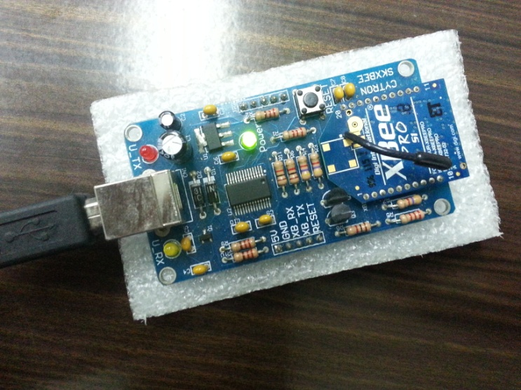

1. Run Zigbee.exe program and select the suitable com port and baud rate. (Used COM3 and 9600 baud rate for this demo).

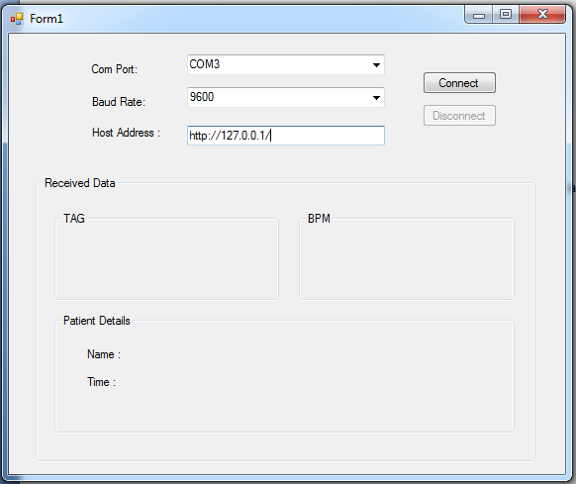

1. Fill Host Address with system address and press Connect. (Demo using http://p.site40.net)

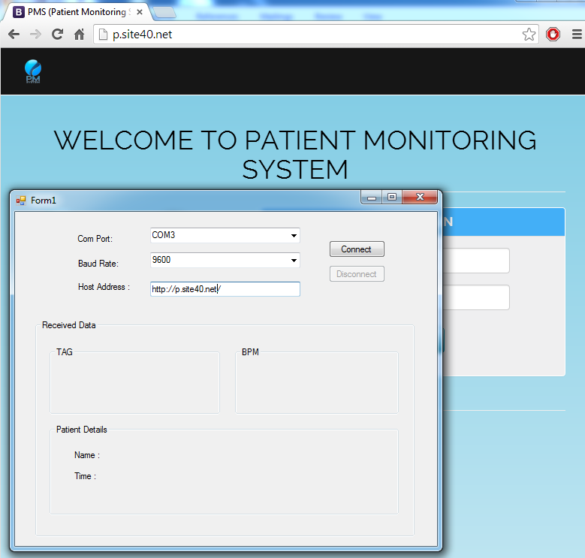

1. ON the router XBEE PRO s1

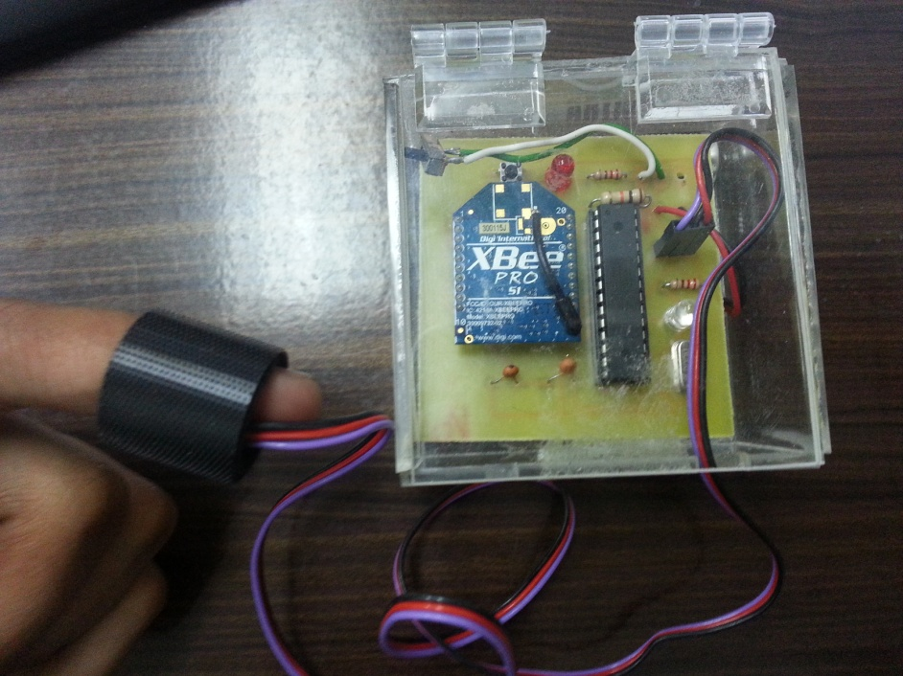

1. The data from router XBEE PRO s1 is shows at PMS system as below.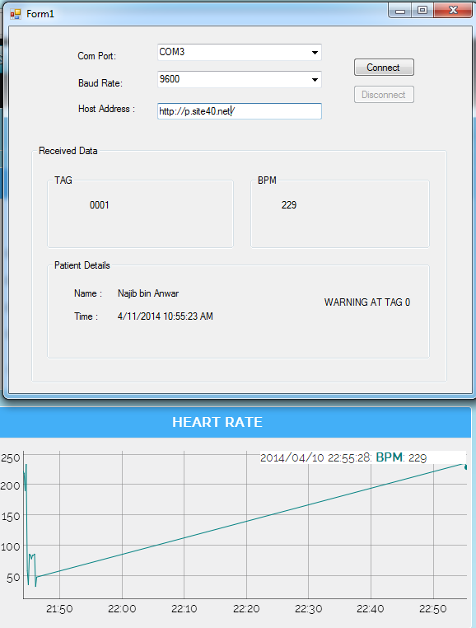

*contact person:*

*Mohd Nur Fahmie*

*fahmie@semarakmotivasi.com*

*0134873831*